PIZZA SALES SQL QUERIES
- KPI’s
1.Total Revenue
SELECT SUM(total_price) AS Total_Revenue from pizza_sales

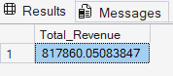

2.Average Order Value

SELECT SUM(total_price)/COUNT(DISTINCT order_id) AS AVG_order_value
FROM pizza_sales;

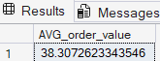

3.Total Pizzas Sold

SELECT COUNT(DISTINCT order_id) AS Total_no_of_Orders FROM pizza_sales;

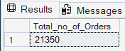
4.Average Pizzas Per Order
SELECT CAST(CAST(SUM(quantity) AS DECIMAL(10,2))/ CAST(COUNT(DISTINCT order_id) AS DECIMAL(10,2)) AS DECIMAL(10,2)) AS Average_Pizzas_Per_Order FROM pizza_sales;

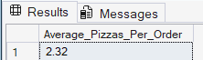
B.Daily Trends for Total Orders
SELECT DATENAME(W, order_date) AS order_day, COUNT(DISTINCT order_id) AS Total_Orders
FROM pizza_sales
GROUP BY DATENAME(W, order_date);
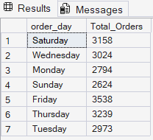

C.Monthly Trend for Orders
SELECT DATENAME(M, order_date) AS order_month, COUNT(DISTINCT order_id) AS Total_Orders
FROM pizza_sales
GROUP BY DATENAME(M, order_date);
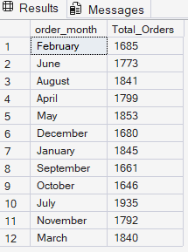
D. % of Sales by Pizza Category
SELECT pizza_category , CAST(SUM(total_price) AS DECIMAL(10,2)) AS total_revenue,
CAST(SUM(total_price) * 100 / (SELECT SUM(total_price) FROM pizza_sales)
AS DECIMAL(10,2)) AS PCT
FROM pizza_sales
GROUP BY pizza_category;

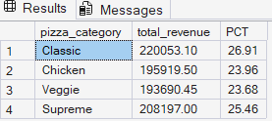
E. % of Sales by Pizza Size
SELECT pizza_size , CAST(SUM(total_price) AS DECIMAL(10,2)) AS total_revenue,
CAST(SUM(total_price) * 100 / (SELECT SUM(total_price) FROM pizza_sales)
AS DECIMAL(10,2)) AS PCT
FROM pizza_sales
GROUP BY pizza_size;

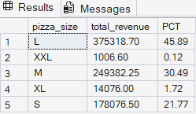
F. Total Pizzas Sold by Pizza Category
SELECT pizza_category , SUM(quantity) AS total_no_of_pizza_sold
FROM pizza_sales
GROUP BY pizza_category

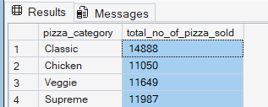

G.Top 5 Pizzas by Revenue

SELECT TOP 5 pizza_name , SUM(total_price) AS price
FROM pizza_sales
GROUP BY pizza_name
ORDER BY SUM(total_price) DESC;

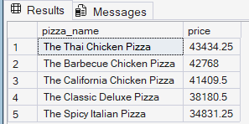

H. Bottom 5 Pizzas by Revenue
SELECT TOP 5 pizza_name , SUM(total_price) AS price
FROM pizza_sales
GROUP BY pizza_name
ORDER BY price ASC;
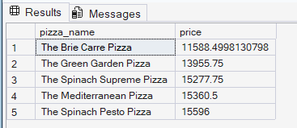

I. Top 5 Pizzas by Quantity
SELECT Top 5 pizza_name, SUM(quantity) AS Total_Pizza_Sold
FROM pizza_sales
GROUP BY pizza_name
ORDER BY Total_Pizza_Sold DESC;

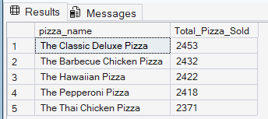
J. Bottom 5 Pizzas by Quantity
SELECT Top 5 pizza_name, SUM(quantity) AS Total_Pizza_Sold
FROM pizza_sales
GROUP BY pizza_name
ORDER BY Total_Pizza_Sold ASC;

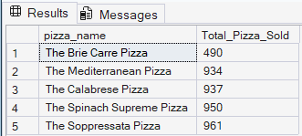

K. Top 5 Pizzas by Total Orders

SELECT Top 5 pizza_name, COUNT(DISTINCT order_id) AS Total_Orders
FROM pizza_sales
GROUP BY pizza_name
ORDER BY Total_Orders DESC;
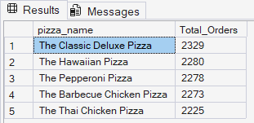

L. Bottom 5 Pizzas by Total Orders
SELECT Top 5 pizza_name, COUNT(DISTINCT order_id) AS Total_Orders
FROM pizza_sales
GROUP BY pizza_name
ORDER BY Total_Orders ASC;

